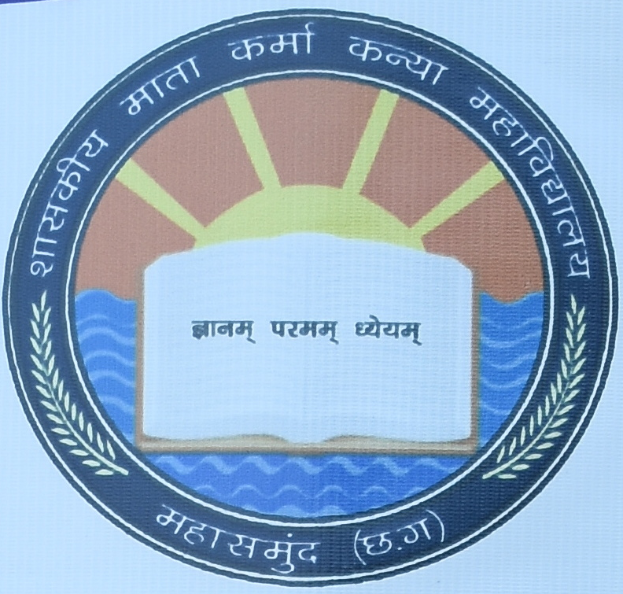
Govt. Mata Karma Girls’ College Mahasamund (C.G)
(NAAC Accredited)
Affiliated to Pt. Ravishankar Shukla University, Raipur
National Webinar On
‘Status of Religion in secular India’

Date: 25 Nov. 2021 Time: 12:00
Organized By - Department of Political Science

Our Distinguished Speakers

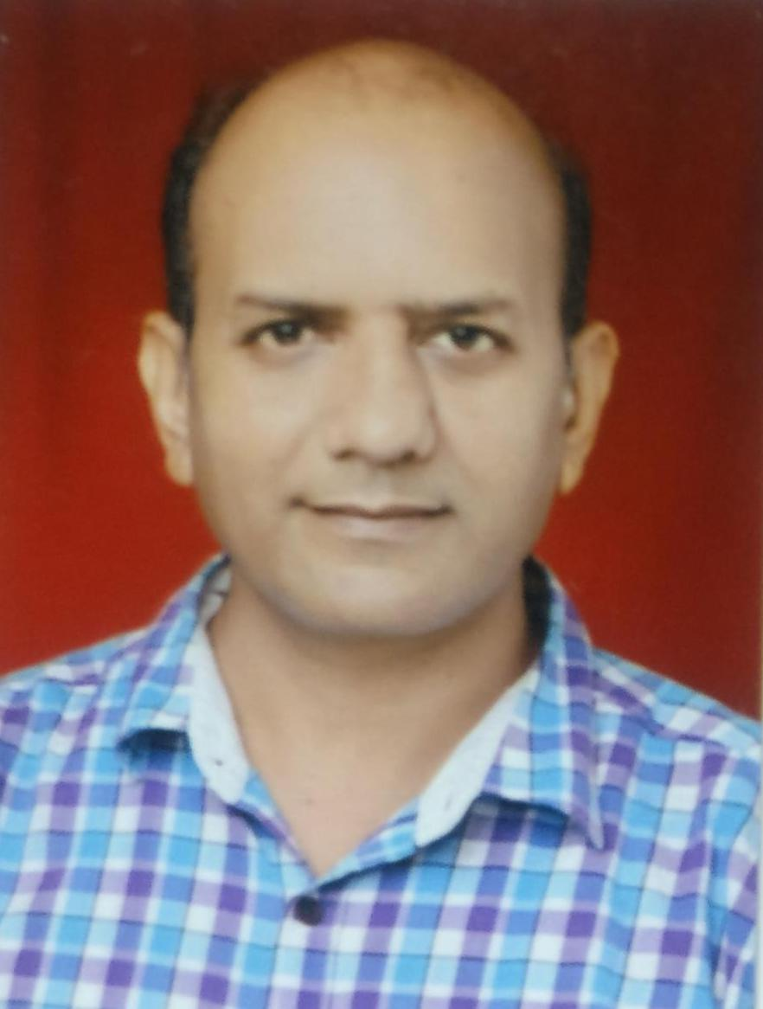 | 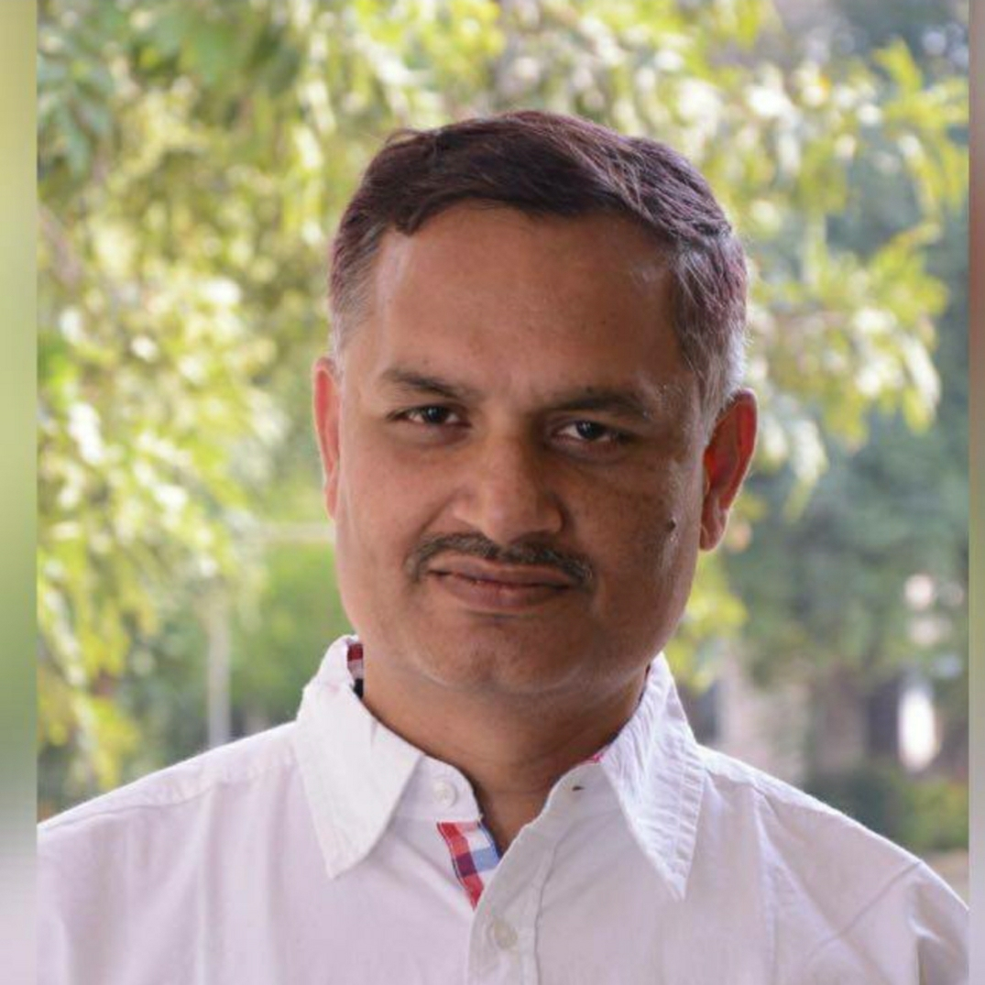
Dr. ALKESH CHATURVEDI  Registrar & Professor,  Dept. of History  Sanchi University of Buddist-Indic Studies, Sanchi (M.P. ) | DR. NEERAJ KUMAR JHA  Associate Professor,  Political Science,  Rani Laxmi Bai Art & Commerce College Gwalior (M.P.)

Registration Details
- Registration fee: Free of Cost (Session will be online via Google Meet)
- Registration link:
https://forms.gle/9nC39isC6fCcnKSp7
- E-Certificate will be issued to all participants after filling the feedback form after session.
- All participants must join the WhatsApp group link after registration.
https://chat.whatsapp.com/I5YPQvLKJKYDaN8VnFwZGH
- For more details contact us at:, 9893442506

Our Team

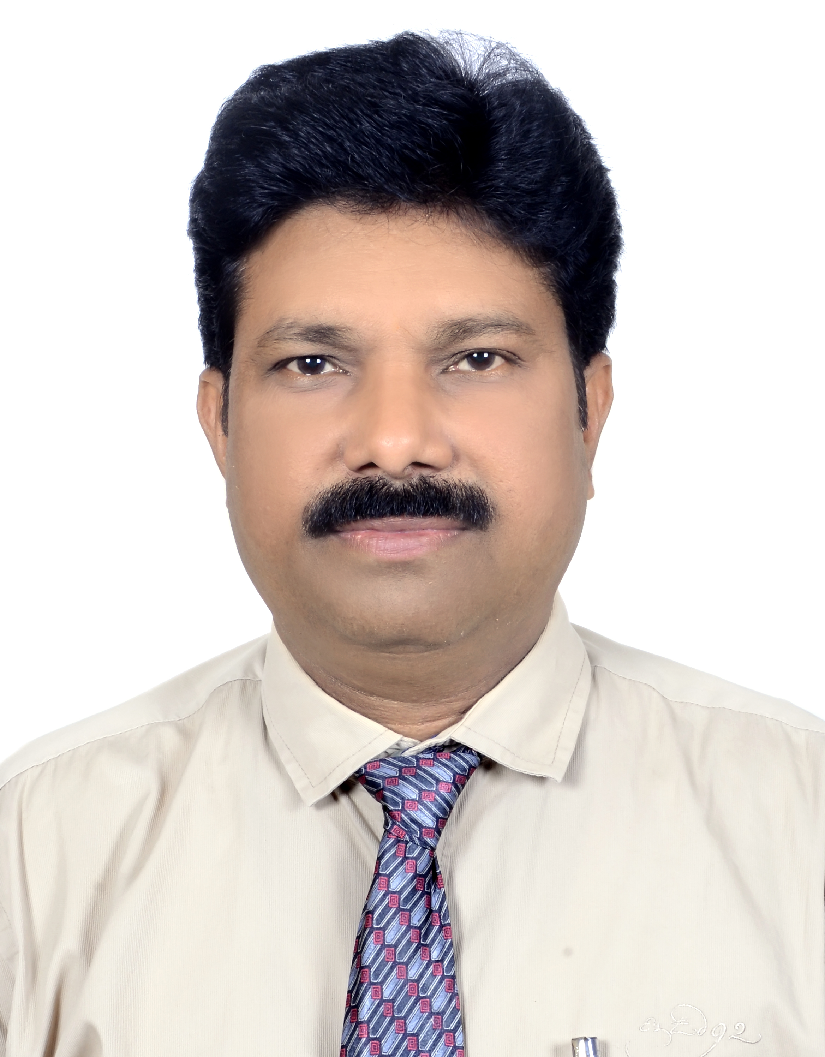 | 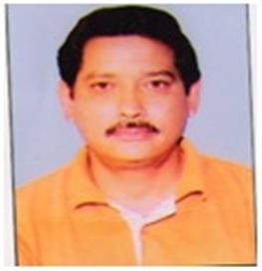 | 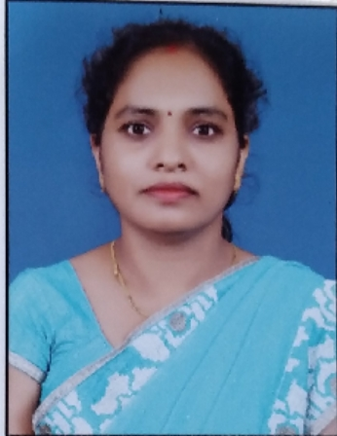
Patron  DR. RAMESH KUMAR DEWANGAN  Principal  Govt. Mata Karma Girls’ College  Mahasamund (C.G.) | Convener  Dr. Sheel Bhadra Kumar  Asst. Professor & HoD  Political Science  Govt. Mata Karma Girls’ College  Mahasamund (C.G.) | Coordinator  Dr. Sarasawati Verma  Asst Professor & HoD, Hindi  Govt. Mata Karma Girls’ College  Mahasamund (C.G.)

Organizing Committee  Dr. Swetlana Nagal, Asst Professor & HoD, Microbiology  Dr. Shalini Verma, Asst Professor & HoD, Geography  MR. V. K. SAHU, Asst Professor & HoD, Sociology  Mr. Ajay Kumar Shrivas, Librarian, Organizing Secretary | Technical Support  Mr. Phalesh Diwan, Asst Grade II  Mr. Gajpati Patel, Asst. Grade II  Mr. Lekhraj Banjare  Smt. Ahilya Bai Lahre  Mr. Vinod Kumar Banjare

